3. Data Flow Diagram (DFD)
This section presents the Data Flow Diagram (DFD) of the Phone Book Management System, based on the functional requirements in Section 1. The system is modelled at two levels: a Level 0 context diagram, which shows the whole system as a single process and its interaction with the external entities, and a Level 1 diagram, which decomposes the system into its main processes and data stores.

3.1 Notation
Symbol | Meaning | Naming rule
Rectangle | External entity | Noun, e.g. User
Circle | Process | Number + verb phrase, e.g. 2.0 Manage Contacts
Open-ended rectangle | Data store | ID + noun, e.g. D2 Contacts
Arrow | Data flow | Noun phrase describing the data, e.g. Contact info

3.2 External entities
Entity | Description
User | A person who registers an account and, once logged in, manages his or her own phone book: contacts, favorites, groups and personal profile.
Admin | The system administrator, who manages all user accounts and monitors system usage statistics.

3.3 Level 0 – Context diagram
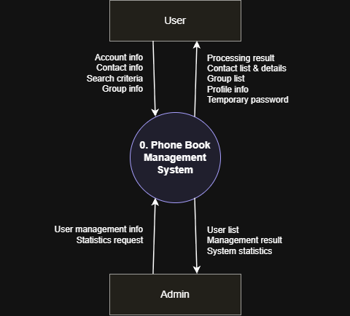

Figure 1. DFD Level 0 – Context diagram of the Phone Book Management System
No. | Data flow | Source | Destination | Description
F1 | Account info | User | System (0) | Registration, login, logout, profile update and password reset data
F2 | Contact info | User | System (0) | Data to add, update or delete a contact; favorite mark
F3 | Search criteria | User | System (0) | Keyword, sort order, favorite and group filters
F4 | Group info | User | System (0) | Data to create, edit or delete a group; assign or remove contacts
F5 | Processing result | System (0) | User | Success or error messages, login status
F6 | Contact list & details | System (0) | User | Paginated, sorted or filtered contacts and contact details
F7 | Group list | System (0) | User | Groups and their contacts
F8 | Profile info | System (0) | User | Personal profile to view and edit
F9 | Temporary password | System (0) | User | New password sent to the user's email
F10 | User management info | Admin | System (0) | Request to view, update or delete user accounts
F11 | Statistics request | Admin | System (0) | Request to view system statistics
F12 | User list | System (0) | Admin | All registered users and their details
F13 | Management result | System (0) | Admin | Result of an update or delete operation
F14 | System statistics | System (0) | Admin | Total users and total stored contacts

3.4 Level 1 – Decomposition diagram
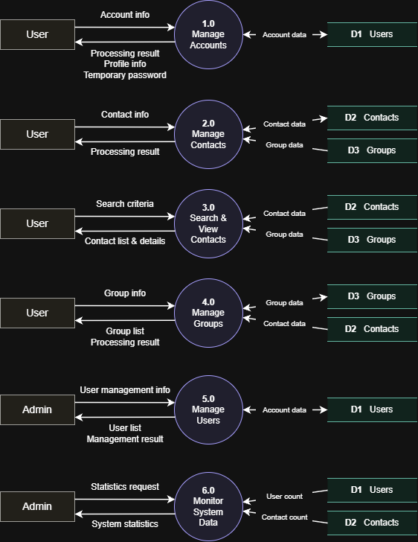
Figure 2. DFD Level 1 – Decomposition of the Phone Book Management System
Note: the entities User and Admin and the data stores D1, D2 and D3 are drawn more than once so that the flows do not cross; elements with the same ID represent the same entity or data store.

3.4.1 Processes
ID | Process | Description | Data stores
1.0 | Manage Accounts | Registers new users (validates input, checks duplicate email, stores a hashed password), logs users in and out, updates the profile (except the email) and resets a forgotten password. | D1 (read/write)
2.0 | Manage Contacts | Adds, updates and deletes contacts (deletion needs confirmation) and marks or unmarks favorites. | D2 (read/write), D3 (read)
3.0 | Search & View Contacts | Displays the paginated contact list and contact details; searches by keyword; sorts by name or creation date; shows favorites; filters by group. | D2 (read), D3 (read)
4.0 | Manage Groups | Creates, edits and deletes groups; assigns contacts to groups or removes them from groups without deleting the contact. | D3 (read/write), D2 (read)
5.0 | Manage Users | Lets the administrator view all users, update user details and delete inactive or violating accounts. | D1 (read/write)
6.0 | Monitor System Data | Computes and displays the total number of users and the total number of stored contacts. | D1 (read), D2 (read)

3.4.2 Data stores
ID | Data store | Content | Related class / table
D1 | Users | User accounts: full name, email, phone number, hashed password, date of birth, address and role. | User
D2 | Contacts | Contact records of each user: full name, phone number, email, address, category, notes and favorite flag. | Contact
D3 | Groups | Groups (categories) created by users and the assignment of contacts to groups. | Group

3.4.3 Data flows
No. | Data flow | Between | Level 0 flow
1 | Account info | User → 1.0 | F1
2 | Processing result | 1.0 → User | F5
3 | Profile info | 1.0 → User | F8
4 | Temporary password | 1.0 → User | F9
5 | Account data | 1.0 ↔ D1 Users | Internal
6 | Contact info | User → 2.0 | F2
7 | Processing result | 2.0 → User | F5
8 | Contact data | 2.0 ↔ D2 Contacts | Internal
9 | Group data | D3 Groups → 2.0 | Internal
10 | Search criteria | User → 3.0 | F3
11 | Contact list & details | 3.0 → User | F6
12 | Contact data | D2 Contacts → 3.0 | Internal
13 | Group data | D3 Groups → 3.0 | Internal
14 | Group info | User → 4.0 | F4
15 | Group list | 4.0 → User | F7
16 | Processing result | 4.0 → User | F5
17 | Group data | 4.0 ↔ D3 Groups | Internal
18 | Contact data | D2 Contacts → 4.0 | Internal
19 | User management info | Admin → 5.0 | F10
20 | User list | 5.0 → Admin | F12
21 | Management result | 5.0 → Admin | F13
22 | Account data | 5.0 ↔ D1 Users | Internal
23 | Statistics request | Admin → 6.0 | F11
24 | System statistics | 6.0 → Admin | F14
25 | User count | D1 Users → 6.0 | Internal
26 | Contact count | D2 Contacts → 6.0 | Internal

3.5 Balancing between Level 0 and Level 1
Every data flow that enters or leaves the system in the Level 0 diagram appears at the boundary of the Level 1 diagram, and no new external flow is introduced.
Level 0 flow | Level 1 flow | Process
F1 Account info | Account info | 1.0
F2 Contact info | Contact info | 2.0
F3 Search criteria | Search criteria | 3.0
F4 Group info | Group info | 4.0
F5 Processing result | Processing result | 1.0; 2.0; 4.0
F6 Contact list & details | Contact list & details | 3.0
F7 Group list | Group list | 4.0
F8 Profile info | Profile info | 1.0
F9 Temporary password | Temporary password | 1.0
F10 User management info | User management info | 5.0
F11 Statistics request | Statistics request | 6.0
F12 User list | User list | 5.0
F13 Management result | Management result | 5.0
F14 System statistics | System statistics | 6.0

3.6 Modelling rules applied
- Data flows only connect a process with an external entity, a data store or another process; there is no direct flow between two entities, two data stores, or an entity and a data store.
- Every process has at least one input flow and at least one output flow.
- Processes are named with verb phrases, while data flows, entities and data stores are named with nouns.
- The processes cover the functional requirements of Section 1 (account management, contact management, search and organization, and system administration), and the data stores correspond to the classes User, Contact and Group.

